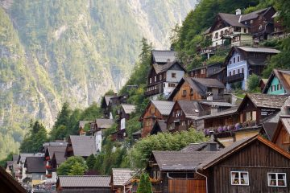 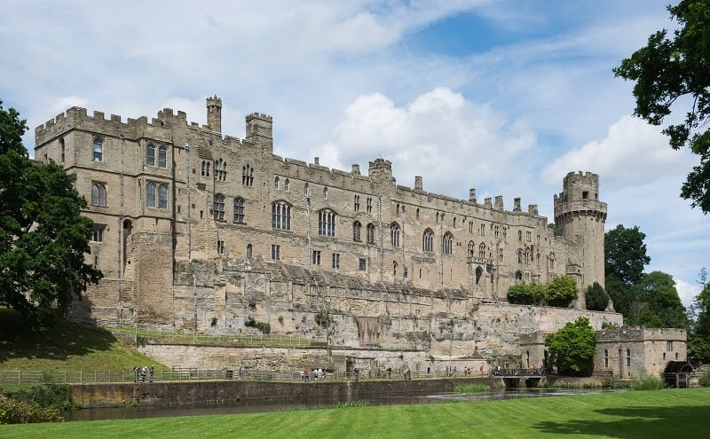 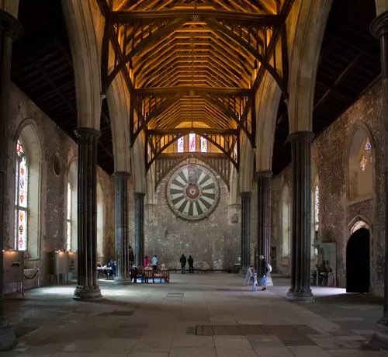 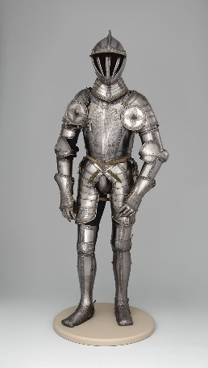 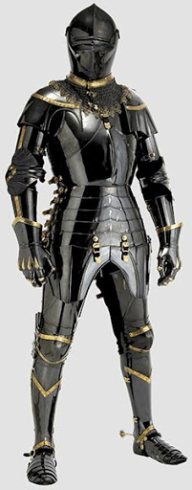

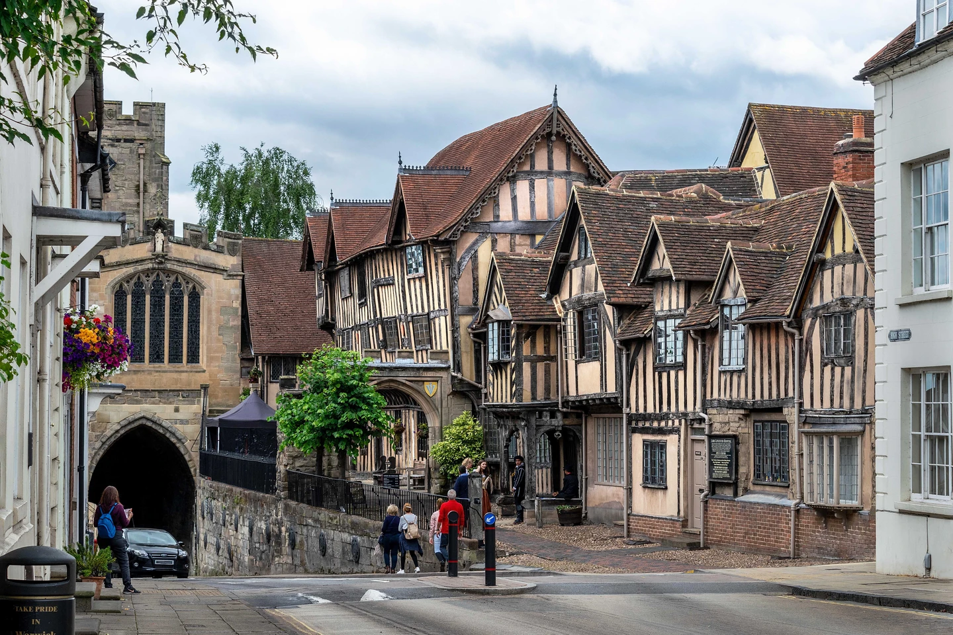 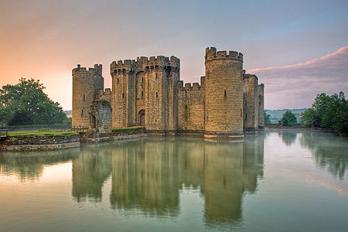 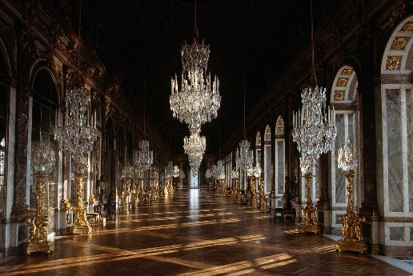 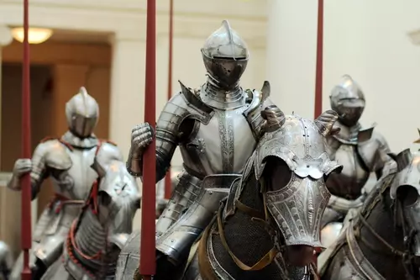

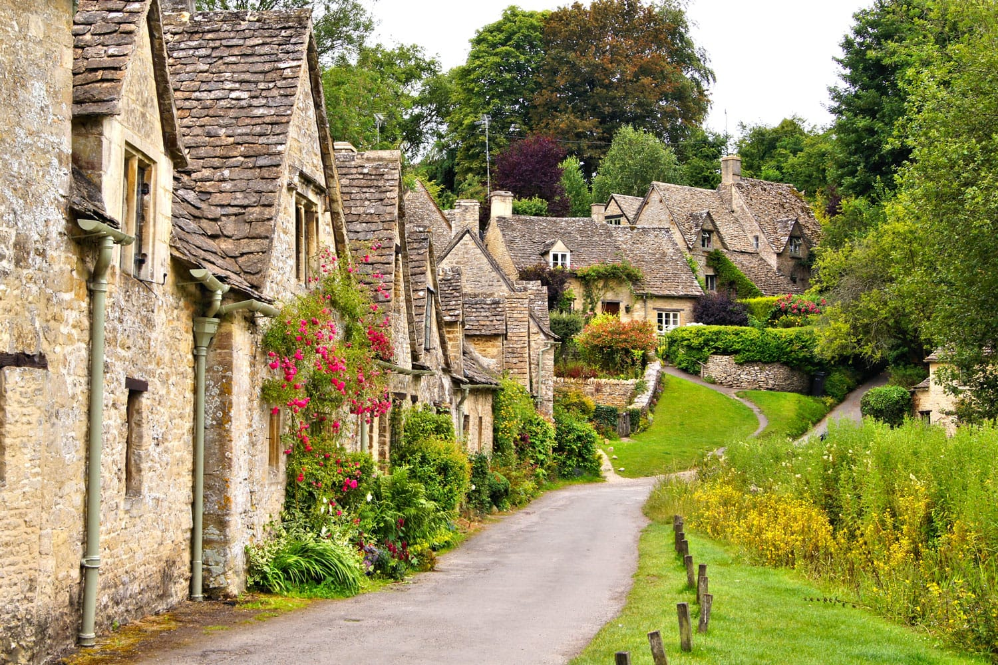 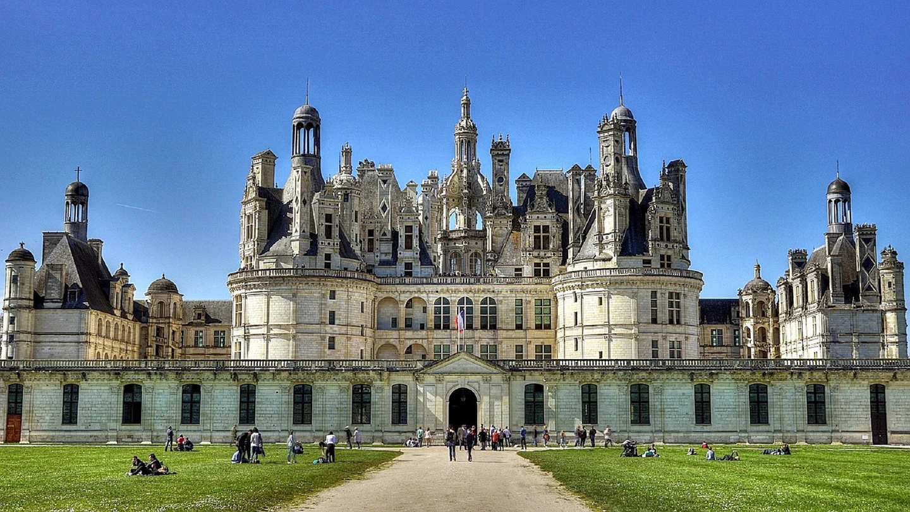 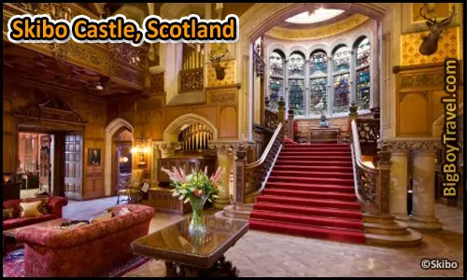 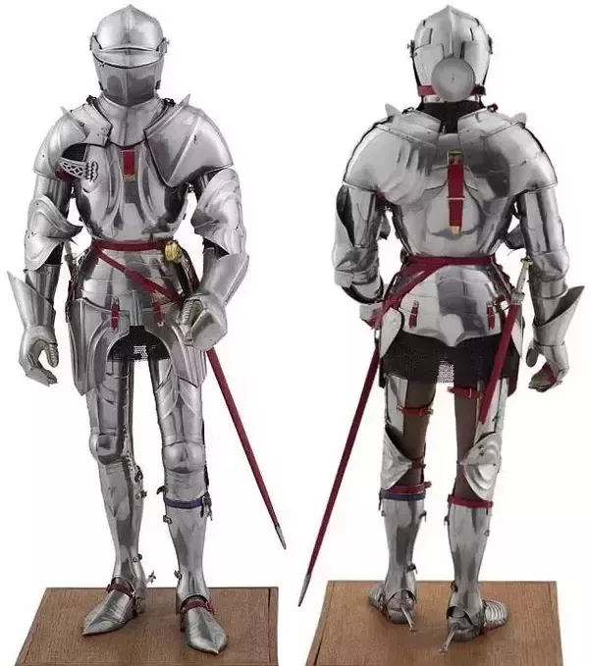

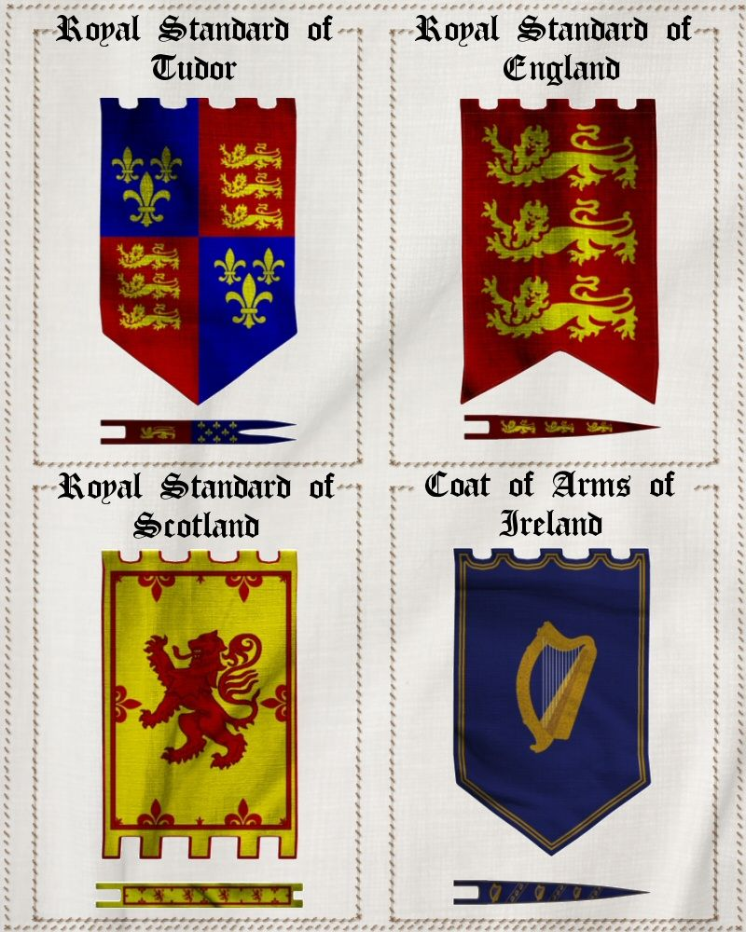 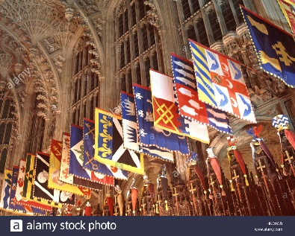 Colours used in House/castle flags are white, red, blue and yellow. Occasionally black and very rarely green.

Villages:

<https://www.jetsetmag.com/travel/destinations/euro-charm-hidden-european-villages-with-old-world-appeal/>

<https://theculturetrip.com/europe/united-kingdom/articles/10-incredible-historical-towns-in-the-united-kingdom/>

<https://www.roadaffair.com/most-beautiful-villages-in-the-world/>

Castle Exteriors:

<https://www.oldest.org/structures/castles/>

<https://en.wikipedia.org/wiki/Castle>

<https://theculturetrip.com/europe/spain/articles/the-oldest-castles-you-can-still-visit-in-the-world/>

Castle Interiors:

<https://www.ancient.eu/Great_Hall/>

<https://www.travelandleisure.com/culture-design/architecture-design/google-arts-culture-app-europe-castles> (virtual tours to see whole interiors)

<https://www.bigboytravel.com/topten/most-amazing-castle-hotels/>

Knight (Armour):

<https://www.metmuseum.org/art/collection/search/23944>

<http://www.medievalwarfare.info/armour.htm>

<https://www.ancient.eu/article/1244/the-armour-of-an-english-medieval-knight/>

<https://www.quora.com/What-was-the-best-helmet-and-armor-style-of-the-Medieval-period>

Castle Banners:

<https://www.pinterest.ph/pin/303570831113041153/>

<https://www.alamy.com/stock-photo-westminster-abbey-church-of-england-interior-henry-vii-lady-chapel-132421979.html>